SILCK Annual Report on Progress/Implementation from the 2014-2016 SPIL
Submitted 04/13/2016
Preface
The Kansas SPIL is the blueprint for the development of integrated, accessible and inclusive communities across the state for all persons with disabilities. It shall be driven by Independent Living philosophy; in that persons with disabilities are empowered to act as leaders making the changes to achieve integrated communities. It shall also be driven by the partnerships invested in its achievement. The SILCK will produce a report which details the state of IL based on each goal and its components annually following the submission of the 704 report to the Administration on Community Living. While the report below shows the statistical data on how many consumers are receiving services or setting goals in the areas of Transportation, Housing, Employment and Outreach, SILCK will also showcase promising practices that are building capacity across the state of Kansas.
The commitment by all of the Centers for Independent Living in Kansas to have staff participate on the SPIL workgroups has been a major factor in the success of achieving the goals of the SPIL. The workgroups have not only completed tasks but a natural peer sharing has developed among the participants and thus created a networking resource and better informed front line staff to assist people with disabilities. The accomplishments of the workgroups are especially significant considering CILs have less staff than just 5 years ago. Continued CIL commitment to the workgroups underlines their value and effectiveness. SILCK also recognizes the level of camaraderie has increased among the CIL network and this is an asset to the State by leading to a significant positive effect in partnerships, advocacy and consistency of services.
While there are measurable increases in goals met and services provided, and partnerships continue to grow and evolve, SILCK feels it’s important to note that there are some struggles. With the passing of the Workforce Innovations and Opportunities Act came additional core services that are required, but no additional funding. CILs in Kansas have been doing more with less, and are already struggling to meet the needs of people with disabilities in their service areas. The IL community in Kansas wholeheartedly supports the importance of the additional fifth core service; acknowledging how vital nursing home transition and diversion services are for people with disabilities to live independently, and youth transition services for youth with disabilities to have opportunities to become productive citizens just as youth without disabilities. While all CILs are continuously looking for ways to increase funding for independent living services, the addition of core services will definitely have a financial impact on Centers that adds to the pressure experienced by them.

Goal 1) Kansas communities and persons with disabilities have an awareness of needs, rights and responsibilities.
Component 1: Persons with disabilities are aware of CILs, the services offered, as well as their rights and opportunities. The Outreach workgroup has reviewed and finalized the universal power point on core services and a few CILs have utilized it for presentations in the target audiences of; General, Youth and Professional. Talking points for each one of the core services was developed to guide staff in explaining what the services are and how they are provided. The Outreach workgroup also worked on figuring out ways that CIL staff could document different pathways of disseminating outreach materials and information consistently. A radio public service announcement was researched, and developed so that all CILs across the state could use the boilerplate script and add their center name and contact info. The group is also working with students at Johnson County Community College on a video public service announcement project to make it professional and accessible, and should have a completed product in 2016. This project is a general video that all centers and the SILCK could use that showcases what CILs offer in our state. The group continues to utilize the statewide branding tagline “Recognizing Disabilities, Emphasizing Possibilities” in the majority of the work they do. An Outreach packet with instructions is being developed so that staff know how to use all of the outreach materials developed by this workgroup and should be completed in 2016.
Component 2: On a statewide level the network of CILs is aware of transportation availability and needs. The Transportation workgroup continued to communicate with the Kansas Department of Transportation, Bureau of Transportation Planning on the regional transit initiatives and implementation of coordination planning and the importance of including disability advocates. APRIL’s guiding principles in addressing transportation needs in rural America, as well as several other articles and resources were shared with the workgroup and encouraged to be used as a source to help transportation advocacy on a local level by CIL staff. Workgroup members reviewed the Kansas DOT regional transit plans for their area and were encouraged to attend local transit meetings to represent the disability community and make sure services reflected accessible needs.
Component 3: On a statewide level the IL Network is aware of housing availability and needs and has coordinated input into the consolidated plans for housing. The Housing workgroup members provided input and comments to the Kansas Housing Resource Corporations regarding the Kansas Consolidated Five Year Plan and 2015 Annual Action Plan. Some of the recommendations included: for the many different programs under the Kansas Consolidated Plan, add accessibility based on the Fair Housing Accessibility Guidelines and universal design of housing to the criteria that will be used to select applicants, provide incentives for the development of affordable, energy efficient housing for both rentals and homeowners, provide education to landlords on what is required for a dwelling to be considered accessible. This workgroup developed a template to assist people with disabilities in filing housing complaints on discrimination and has compiled a list of housing resources to share among CIL staff. The Housing workgroup developed a consumer training that was showcased at the Kansas Disability Caucus in August 2015. The topics of this training included; Accessibility Modifications in Rental Housing, Service Animals in Rental Housing, Finding Rental Housing with a Challenging Rental History, and Addressing the Conditions of Rental Housing. The comprehensive spreadsheet that lists accessible and affordable housing options by county in the following categories: low rent, Section 8, Rent Subsidy, USDA Section 515, Senior, Disability, Senior/Disability, and Family has been updated. The workgroup continues to research and share training opportunities and workshops for Fair Housing regionally and nationally.
Component 4: Integrated competitive employment is attainable for persons with disabilities, and myths about hiring them are dispelled. Persons with disabilities are aware of the benefits of employment and services available to them to help attain employment. The Employment workgroup used flash drives to distribute the SPIL Employment resources and the Employer toolkit to all KS CILs, this allowed for CILS to be able to add local resources, keep info updated as needed and to reproduce the info to hand out to staff or employers. A coordinated plan for delivery will be determined and distributed to all the CILs. The Employment workgroup compiled a list of employers who would be willing to mentor other businesses on the positive value of hiring people with disabilities. This workgroup developed a training on employment for consumers that they presented at the Kansas Disability Caucus in August of 2015. Training topics included; consumer soft skills, accommodations, and resources. This group has plans to provide an employment training to CIL staff in 2016 as well.
Goal 2) Kansans will have program and physical access to support integrated inclusive community living.
Component 1: Kansas youth with disabilities access CIL and youth mentoring services to increase their independence. The FFY 2015 704 data shows that 265 consumers requested assistance and 259 of those requests received services to work towards a desired goal in youth transition. This is an increase in services of 60% over FFY 2014 where 167 consumers requested services and 161 received youth transition services. CILs collaborated in several different ways to reach out and educate youth in their areas, some of those ways included: Disability Mentoring Day projects, Living Well with a Disability presented in the school, youth employment projects, youth advocacy projects, presentations to special education teachers at a transition forum, Life After High School panel discussions and various community education events. Kansas Youth Empowerment Academy (KYEA) which is the youth mentor contractor for the SPIL coordinated several programs that served youth with disabilities. Those programs include: Kansas Youth Leadership Forum -20 participants, Empower Me Series workshops -53 participants, ICON -3 interns, Empowerment Services- 8 participants.
Component 2: Kansas IL consumers gain access to needed transportation. The FFY 2015 704 data shows 189 consumers requested assistance with transportation and 153 of those requests received services towards transportation goals. This is a decrease in services of 28% over FFY 2014 where 239 consumers requested services and 212 received services toward transportation goals. Furthermore, data shows that 1,175 goals were set, 501 goals were achieved and 625 goals were still in progress for FFY 2015. In comparison FFY 2014 had 1,078 goals set, 436 goals achieved and 590 goals still in progress. And lastly in 2015, 522 consumers requested access to transportation, 310 achieved access and 187 had access still in progress. In 2014 11,341 requested access, 863 achieved access and 302 had access in progress. CILs advocated with providers to enhance accessibility, available options and routes, as well as joining and providing expertise to various transportation councils and advisory boards in their communities across the state.
Component 3: Kansas IL consumers receive services which support them to live independently in their community of choice. The FFY 2015 704 data shows 2768 Community Based Living goals were set, 546 goals were achieved and 2174 goals are still in progress. Nursing Home Relocation shows 209 goals were set, 99 goals were achieved and 106 goals are still in progress. In comparison FFY 2014 704 data shows 1994 Community Based Living goals set, 443 goals achieved, and 1524 goals in progress. Nursing Home Relocation shows 148 goals set, 54 goals achieved and 94 goals still in progress. CILs provided education on services and resources at local health fairs and community events, were active in providing feedback and recommendations to the Managed Care Organizations and at KanCare forums, as well as providing Transitional Living Services to Money Follows the Person participants.
Component 4: Kansas IL consumers increase independence by setting and achieving vocational goals, and by gaining competitive integrated employment. The FFY 2015 704 data shows that 4161 consumers requested vocational services and 4109 of those received services. This is an increase of 776% over FFY 2014 where 543 requested services and 529 received services. Furthermore 2015 data shows 583 vocational goals were set, 136 goals were achieved and 383 goals are still in progress. In comparison, 2014 information shows that 528 goals were set, 136 goals were achieved and 383 goals were still in progress. The Department of Labor statistics for Kansas are from a 2010-2014 survey and show a total labor force of 1,507,348 with 85,266 being a person with a disability. The survey lists the unemployment rate as 6.6% total, and 14.3% for people with disabilities. In comparison FFY 14 showed the Kansas DOL statistics from the 2009-2013 survey with a total labor force of 1,387,885 with 87,784 being a person with a disability and the unemployment rates as 6.9% total and 15.2% for people with disabilities. Some CILs have provider contracts with KRS to provide employment services, others have independent grants to fund their employment services and others simply assist in employment as independent living skills training. More and more Centers are looking into how they can partner with Workforce Investment Centers to assist consumers with additional employment resources and services.
Component 5: Kansas IL consumers have the knowledge to access healthcare resources. The FFY 2015 704 data shows that 5,368 consumers required access, 3,731 achieved access and 1,579 have access still in progress. In comparison FFY 2014 704 data showed 5,213 consumers required access, 3,142 achieved access and 1,833 had access still in progress. CILs promoted awareness of healthcare options and information by participating in events such as health fairs, civic engagements and peer support groups, and by participating on various community coalitions and boards.
Goal 3) Kansas Centers for Independent Living have the network capacity sufficient to meet the needs of the communities they serve and the consumers who reside there.
Component 1: CIL funding opportunities. CILs continue to work on efforts to diversify funding in provision of services. Examples of this are the partnerships with Managed Care Organizations (MCO) to fund home modifications, continued referrals made by the MCO increasing use of the Money Follows the Person grant to assist consumers in relocating from a nursing facility, increased use of Kansas programs such as Working Healthy and WORK to assist consumers in gaining employment, partnership with an MCO through a trial grant project related to employment, various other grants, use of volunteers, county funding and sharing of successful fundraising ventures among the CIL network.

Component 2: Training of staff and board. CILs worked together to identify and utilize trainings across the network on many areas of practice including serving underserved populations, IL Philosophy, financial management and board training. Three SPIL workgroups are developing types of training resources to share with all of the CILs. CILs continue to use ILRU, NCIL and ILNET webinars and resources.

Component 3: Partnerships. Connections with other service providers in the community increased offering more opportunities for referrals and increasing quality of wraparound services offered to CIL consumers. Some areas of focus were assistive technology, employment, housing, the Hispanic population, mental health organizations, transit councils, government advisory committees, homeless shelter residents and disability awareness, education and transition for schools. New partnerships were established for referrals to and from the service provider to offer better services and reach more consumers. One CIL focused on collaboration with KU to build community capacity, assess community needs, analyze barriers and goals and develop action plans for intervention and increased participation. Another CIL partnered with a national movie theatre chain to offer monthly disability friendly movie events in their area which have been very successful in providing social and community time for up to 40 individuals with disabilities per month.

Component 4: Services. Populations of persons with disabilities targeted for outreach included the deaf and hard of hearing community, persons who are low vision or blind, the Hispanic population and youth. Strategies included connections to organizations serving those populations or a subset of a population, staff training focused on underserved populations, hiring bi-lingual staff, having disability specific peer groups, and having Orientation and Mobility Specialists on staff.

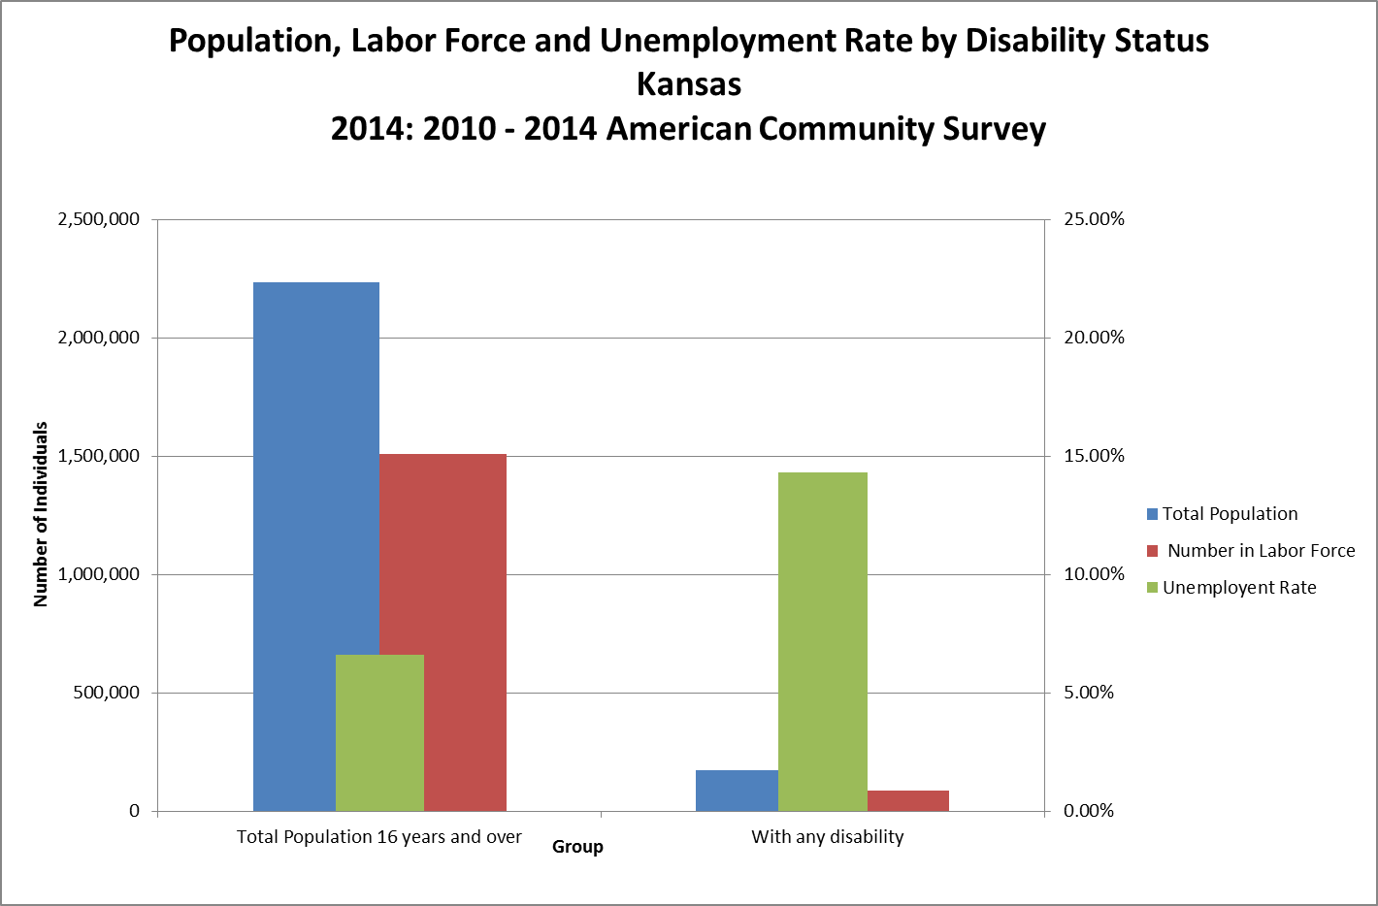

Labor Force and Unemployment Rate by Disability Status
Kansas
2014: 2010 - 2014 American Community Survey, 5 Year Estimates
Group | Total Population | Number in Labor Force | Unemployent Rate
Total Population 16 years and over | 2,236,421 | 1,507,348 | 6.60%
With any disability | 174,368 | 85,266 | 14.30%
Source: Kansas Department of Labor, Labor Market Information Services, U.S. Census Bureau, American Community Survey

